EXISTING INJURY FORM
This form is to be completed by parents or carers when they bring a child to The Phoenix Kindergarten with a pre-existing injury.
Name of child

Date of injury

Date injury reported

Reported by

Nature of injury

How was the injury obtained?

Any treatment or medical advice sought

Any ongoing care requested

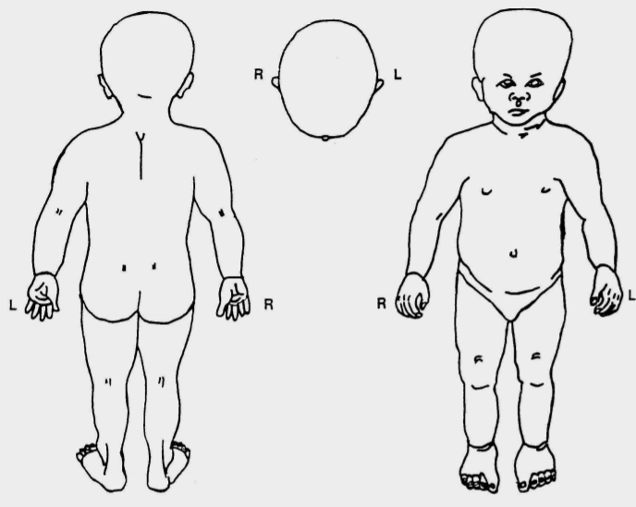

Parent/Carer signature:__________________________________________

Staff signature: ________________________________________________

DSL informed: Yes/No

